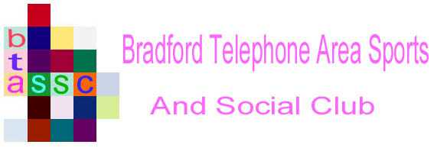

NEWSLETTER

Issue 44 - February 2026

2026 AGM and Winding Up Meeting
Due to our impending “closure”, the Executive Committee have decided to defer the 2026 AGM until Monday, 13th July 2026.
The accounts for 2025 have been audited and attested as a true and accurate record of our transactions. Also, we have no need to elect/re-elect officers to see us through the closure.
This will allow us to reduce the number of meetings this year, to help us eke out our funds.

Immediately after the AGM, we will hold a “Winding Up” meeting to agree how to use what remains of our funds.
Now that NEZRA has closed and we have CEASED all membership payments, we will have NO more income in 2026 and will run down our funds through subsidies for events as normal and grants to the Walking Group and Golf Society.

A notice will be issued nearer the time to advise details of the AGM and Winding Up meeting.

Membership
Members who paid by Deductions from Monthly pay, will notice that their last payment was in December 2025. Arrangements were made with Pay Groups to CEASE further payments. If any member is still showing deductions for NE Sports and Social Club (Bradford) or something similar, please contact the Secretary, Barry Lamb at barry.lamb@btinternet.com
Members who paid an Annual amount in 2025 will not be asked to make any further payments.

Lottery
With no more income, the monthly Lottery has been closed, but as several members have contributed over the past 12 months, there was a residual amount left in the pot. This has been paid out to 3 lucky winners. See the web site for details.
Many thanks to all participants over the years!

Events and Claims
All members are still eligible to claim a subsidy for events as normal, while funds last.
Please note that, due to our financial situation, we have reduced the Annual Limit per member to £80
Please submit claims by email in the period leading up to the event, or immediately afterwards. Payments will be made by bank transfer.

Claims forms for all events are on our web site; www.btassc.com – just follow the links in the left-hand margin of the home page.
Please note that all ticket receipts/invoices must show the members name.

Walking Group
The Walking Group will continue with their monthly weekend walks, usually on the 3rd Sunday of each month. Notices will be sent in advance of each event giving full details. If you’d like to know more, check out the details on our web site; www.btassc.com or contact Brian Campbell at brian.2campbell@btinternet.com
The Walking Group is planning to keep going after BTAS&SC closes, to maintain these active, social occasions.

Golf Society
The Golf Society has a full programme of events for 2026 which can also be found on our Web Site www.btassc.com - just click onto the Golf Link on the left-hand side of the Home Page.
For more details contact Richard Benton at richbenton31@gmail.com
The Golf Society has a plan in place to continue after BTAS&SC closes, to maintain these popular, active occasions.

Feedback
If you have any questions about the “Winding Up”, or event claims, please get in touch with the Secretary, Barry Lamb at barry.lamb@btinternet.com

